Project 3:

Housing Discrimination and Algorithmic Bias
  - By Group 7

Group Members:
- Richard Hoehn (richardhoehn)
- Hector Rogel (rogel9007)
- Isaiah Osborne(IMOsbo)
- Karson Woods (Kwoods132)

Introduction
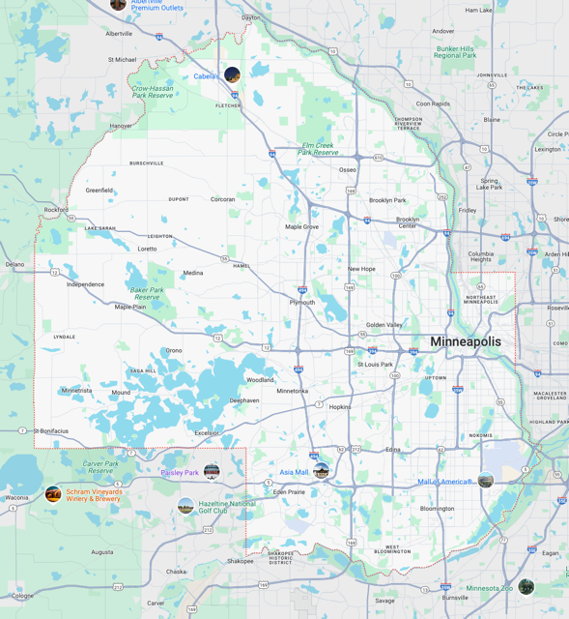
Housing discrimination has played a major role in shaping economic and social inequalities in the United States. While legal barriers like racial covenants and redlining were banned decades ago, their long-term impact continues to influence property values, mortgage lending, and generational wealth. Today, algorithm decision-making has replaced human judgment in many financial processes, including mortgage approval. While these systems are intended to be neutral, they often reinforce historical disparities due to biased data they rely on.
This project focuses on Hennepin County, Minnesota, where past housing discrimination has left a measurable impact on modern lending patterns. By analyzing the relationship between property values, neighborhood demographics, and mortgage approvals, we investigate whether algorithmic lending models continue to perpetuate historical biases.

Embedding of Historical Biases in Modern Data
Modern datasets on housing and mortgage lending indirectly encapsulate many types of historical biases. Property values, per the “mapping Prejudice Project [2], in lots of neighborhoods previously subject to racial covenants have demonstrated higher average values today, reflective of long-term economic advantages accruing from historical exclusivity. Conversely, areas historically marginalized through redlining continue to exhibit lower property values and limited investment, perpetuating a cycle of disadvantage.
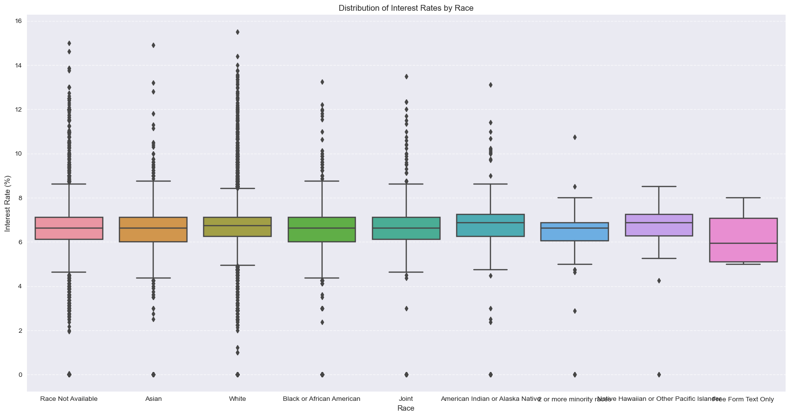
Figure 1 In this figure one can see the tails of White Owners is far larger than Black
The provided dataset(s) indicates a correlation between covenant density and contemporary property values. Properties historically protected by racial covenants consistently exhibit higher valuations. Interestingly, data collection processes also show a bias—higher-priced properties disproportionately lack racial demographic information – which in many cases seems odd. The absence of racial data in high-value transactions could indicate systemic biases in data collection practices, potentially obscuring racial disparities and misrepresenting true demographic impacts.

Methodology & Processes
To analyze the role of historical discrimination in modern lending, we followed these steps:
For the data collection and preprocessing part of the project, we used a preprocessed dataset covering density, property values, demographic statistics, and mortgage lending approvals in Hennepin County. The data sources included were Mapping Prejudice Project (historical racial covenants), Census TIGER/LINE Files (census tract boundaries), and HMDA Data Browser (mortgage lending statistics).
In the data bias analysis part, we examined how historical racial covenants correlate with modern property values, economic indicators, and neighborhood demographics. We also identified patterns of investment disparities and wealth accumulation in historical segregated areas.
For the algorithmic bias analysis, we investigated whether mortgage approval rates and loan terms differ significantly across neighborhoods with high vs. low covenant density. We also evaluated potential proxy variables (property values, neighborhood characteristics) that may unintentionally reinforce racial bias in lending models.

Data Bias Analysis
Looking at the dataset, there definitely appears to be both societal bias and bias in their collection methods.
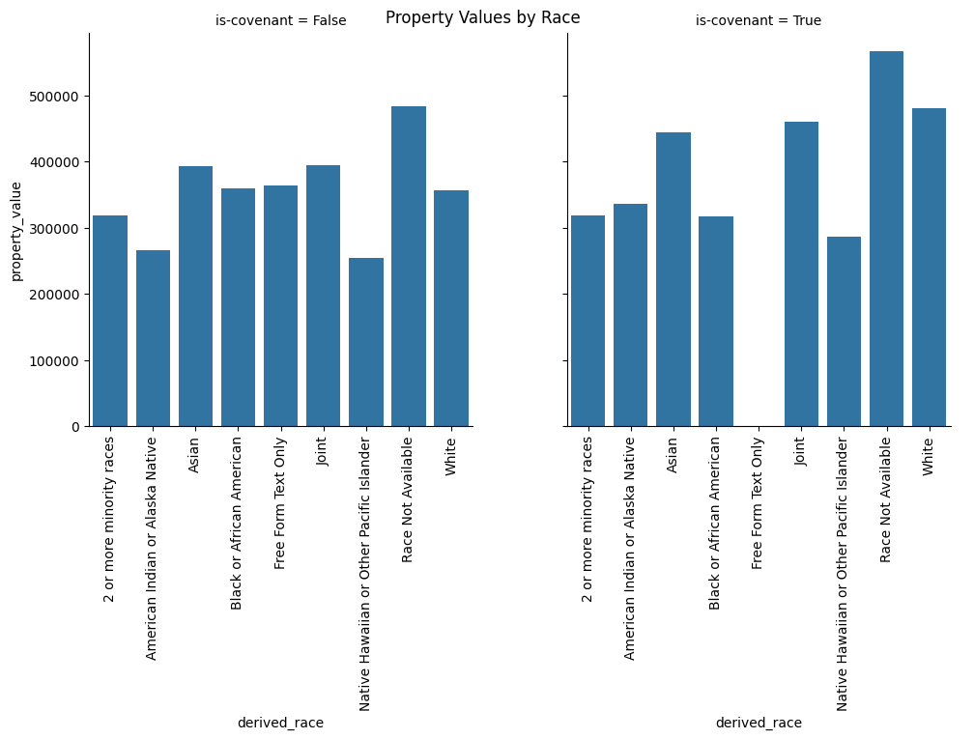Figure 1: Difference between prices between house with covenants or without covenants
In the graph above, we can see the average property values across each of our race and covenant categories. As expected from the historical context, it looks like the properties that had covenants have higher property values. However, besides this, it looks like the properties that don’t have race data available consistently have higher prices, which is unexpected. It looks like whatever process they used is biased toward not including race information for higher-priced properties. Whether this is caused by the data simply not being available or other societal factors, this could be a significant source of bias in our dataset.
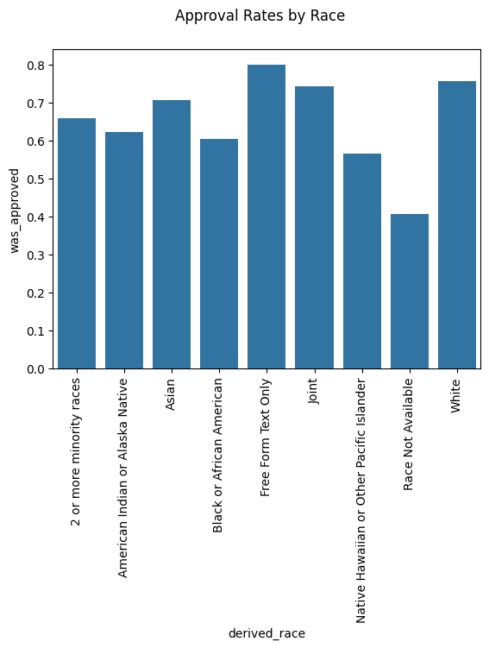
Figure 2: Loan Approval Rate by Race
From this graph, we can see that loan approval varies significantly with race, with white home owners having the highest loan acceptance rate (“free form text only” has 5 houses, so it doesn’t statistically count.) However, our “race not available” home owners have a significantly lower approval rate. Considering that “race not available” home owners also tended to have houses that were worth more than average, so it is surprising that they tend to have such low approval rates. I think this is probably bias in their data collection methods – maybe they were relying on houses being sold to collect demographic information, which could skew the overall results. Whatever the cause of this bias, it definitely could affect the predictive ability of our model.

Algorithmic Bias Analysis
After evaluating the dataset, there appears to be some form of algorithmic bias. Some notable forms of bias came in the form of derived race, tract minority population percent, and tract to msa income percentage.
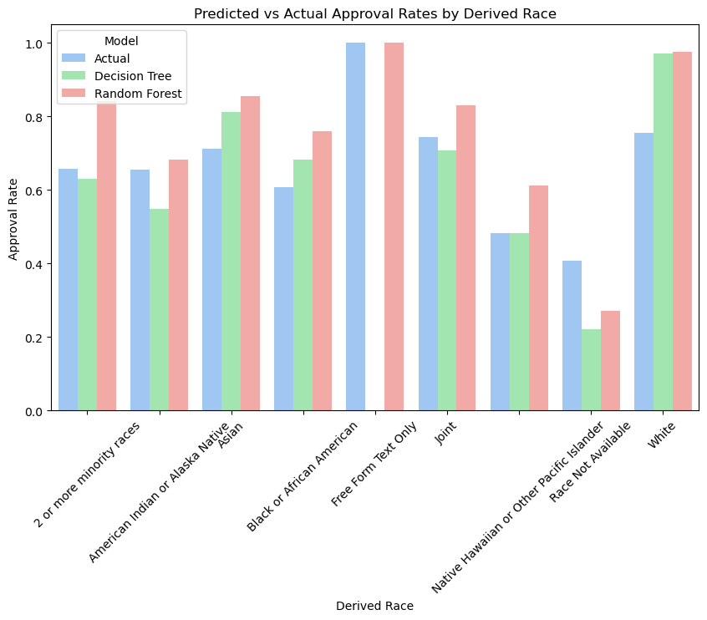
Figure 3: Predicted vs Actual Approval Rates by Derived Race
Looking at predicted vs actual approval rates, we can already see there are some large discrepancies in the values we got. Most notable are the predicted vs actual approval rates for white people. The actual approval rate for white people was around 76% whereas their predicted approval rates were around 97%. This is indicative of some form of racial bias as we’re highly more likely to approve white people based off the selected features for our predictive models. This also holds true for Asians with an actual approval rate of around 71% with a predicted approval rate of around 81% to 85% depending on the predictive model.
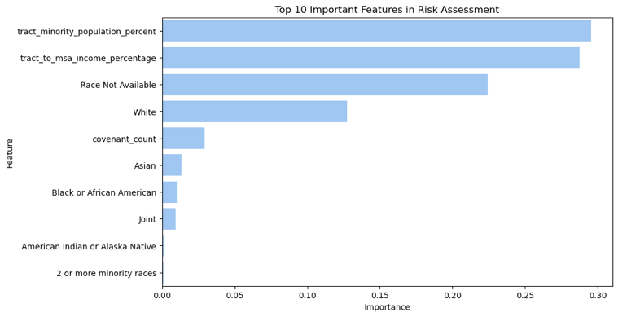
Figure 4: Top 10 Important Features in Risk Assessment
Looking at feature importance for risk assessment, some of the more important ones were tract minority population percent, tract to msa income percentage, and whether or not someone was white. With tract minority population percent being a rather important feature at 29.54%, our model is likely capturing a significant portion of bias from this specific variable. For example, it’s possible that tracts with a higher minority population are negatively impacting their predicted approval rates which would coincide with the lower predicted approval rates they have compared to white people. Another interesting form of racial bias that we can see is that white and Asian people are given more importance when it comes to risk assessment than other races.
Overall, there are multiple forms of bias that affect our predictive model. If we were to use this model for evaluating whether someone should be approved or not, we would likely want to explore some bias mitigation techniques such as reweighting the data.

Discussions
In this section we are looking at various implications regarding modern lending and options for mitigations and respective strategies.

Implications for Modern Lending
Lenders often claim that algorithms remove human bias making. However, our analysis shows that bias does not need to be explicitly programmed into an algorithm for it to exist. It can emerge from the data itself. If left unchecked, these biases can continue limiting homeownership opportunities for marginalized groups and worsening economic inequality.

Proposed Mitigation Strategies
To reduce bias in lending, institutions must:
- Increase transparency in how lending models assess risk.
- Regularly audit algorithms for unintended bias.
- Consider alternatives risk assessment models that minimize reliance on historical biased variables.
- Encourage fair housing policies that address systemic inequalities beyond algorithmic decision-making.

Conclusions
This project highlights how historical housing discrimination is embedded in modern mortgage lending practices. While lending algorithms are meant to be neutral, they often reflect and reinforce past biases rather than eliminating them. Addressing these disparities requires a proactive approach. One that goes beyond improving algorithms and tackles the root causes of housing inequality.

Ramsey Data Work
We originally tried to incorporate data from Ramsey County. We started by exploring the original UMD data repository to see if they had any information for Ramsey County; unfortunately, the processed data only included Hennepin County. After exploring UMD’s data repositories further, we found the entire covenant dataset as an ArcGIS feature layer available from UMD [1]. Once finding that dataset, we started downloading it and filtering it down to just Ramsey County. Ultimately, we were not able to get the address geolocation and spatial joins to ever work properly, despite spending a large amount of researching the dataset.

Works Cited
[1] “Layer: All_Covenants_8_4_2018 (ID:0).” Available: https://services.arcgis.com/8df8p0NlLFEShl0r/ArcGIS/rest/services/All_Covenants_8_4_2018/FeatureServer/0. [Accessed: Mar. 19, 2025]
[2] “Mapping Prejudice Project”. (2025). Racial Covenants and Property Values in Hennepin County. Retrieved from https://mappingprejudice.umn.edu/

